ROYAL OAK INTERNATIONAL SCHOOL
SR. SEC. C.B.S.E. AFFILIATED (2021-22)
PT-II SYLLABUS OF CLASS IX

ENGLISH
Reading: Unseen Passage
Writing Skills: Article writing & Story writing
Grammar : Gap Filling, Editing or omission, Sentences reordering
Literature : Prose: L3: The Little Girl
Poem: P3: Rain on the Roof
SR: 3 : Iswaran the Story Teller

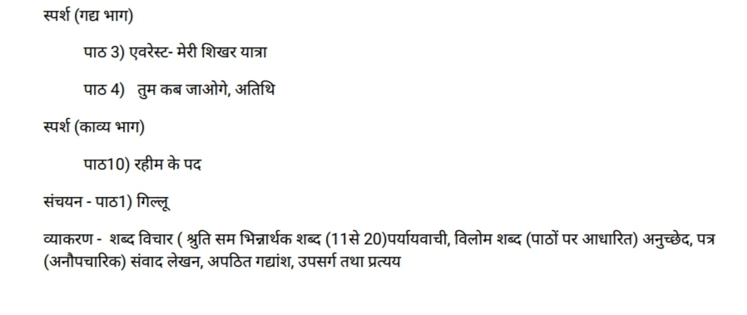
HINDI
MATHS
Chapter-3
Chap,ter-4
Chapter-6

SCIENCE
Chemistry:
Unit-1 Matter in our Surroundings
Topics: Latent Heat, Effect of change of pressure, Evaporation, Factors affecting evaporation, Two more states of matter
Unit-2 Is Matter Around Us Pure
Topics: Pure & Impure Substances, Mixtures, Types of mixtures, Solutions, Suspensions, Colloids.

Physics:
- laws of motion

Biology:
- Fundamental unit of life(complete chapter)

SOCIAL STUDIES

ECO L 1 (The story of Palampur )
POL. L 1 What is democracy and why democracy)

INFORMATION TECHNOLOGY

Unit-A2: Self Management Skills
Unit-B4: Electronic Spreadsheet

